[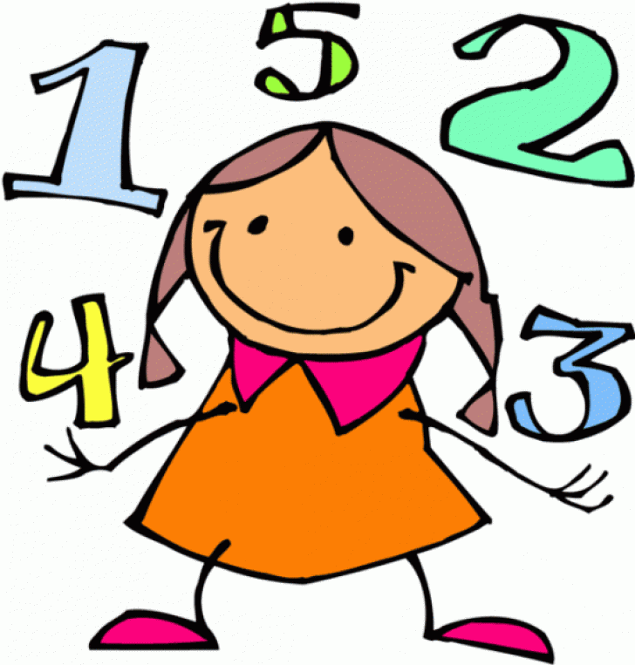](https://www.google.com/url?sa=i&rct=j&q=&esrc=s&source=images&cd=&ved=2ahUKEwjn-_a118ziAhWHF3IKHbjoBgMQjRx6BAgBEAU&url=http://www.thelockinmovie.com/tag/math-clip-art-images-banners/&psig=AOvVaw34i9IaWWi2NOZMGVJhqrHn&ust=1559629651136099) **Learning in KZ!** [](https://www.google.com/url?sa=i&rct=j&q=&esrc=s&source=images&cd=&ved=2ahUKEwipz_7b18ziAhXIX30KHchAC0QQjRx6BAgBEAU&url=https://scubasanmateo.com/explore/detective-clipart-maths/&psig=AOvVaw34i9IaWWi2NOZMGVJhqrHn&ust=1559629651136099)

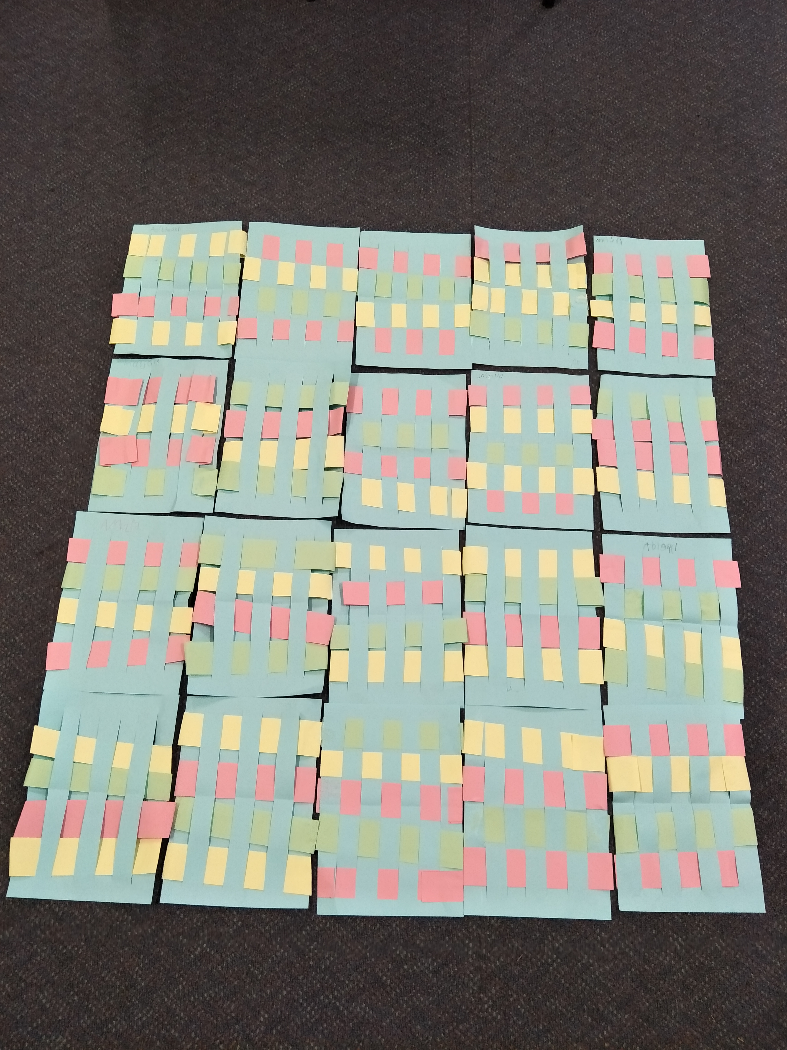[](https://www.google.com/url?sa=i&rct=j&q=&esrc=s&source=images&cd=&ved=2ahUKEwipz_7b18ziAhXIX30KHchAC0QQjRx6BAgBEAU&url=https://scubasanmateo.com/explore/detective-clipart-maths/&psig=AOvVaw34i9IaWWi2NOZMGVJhqrHn&ust=1559629651136099)

KZ were challenged to create a paper weave by placing a strip of coloured paper **over** and **under** repetitively through the slits.

In Mathematics, KZ have been learning all about position. We explored language that can be used to describe the position of an object.

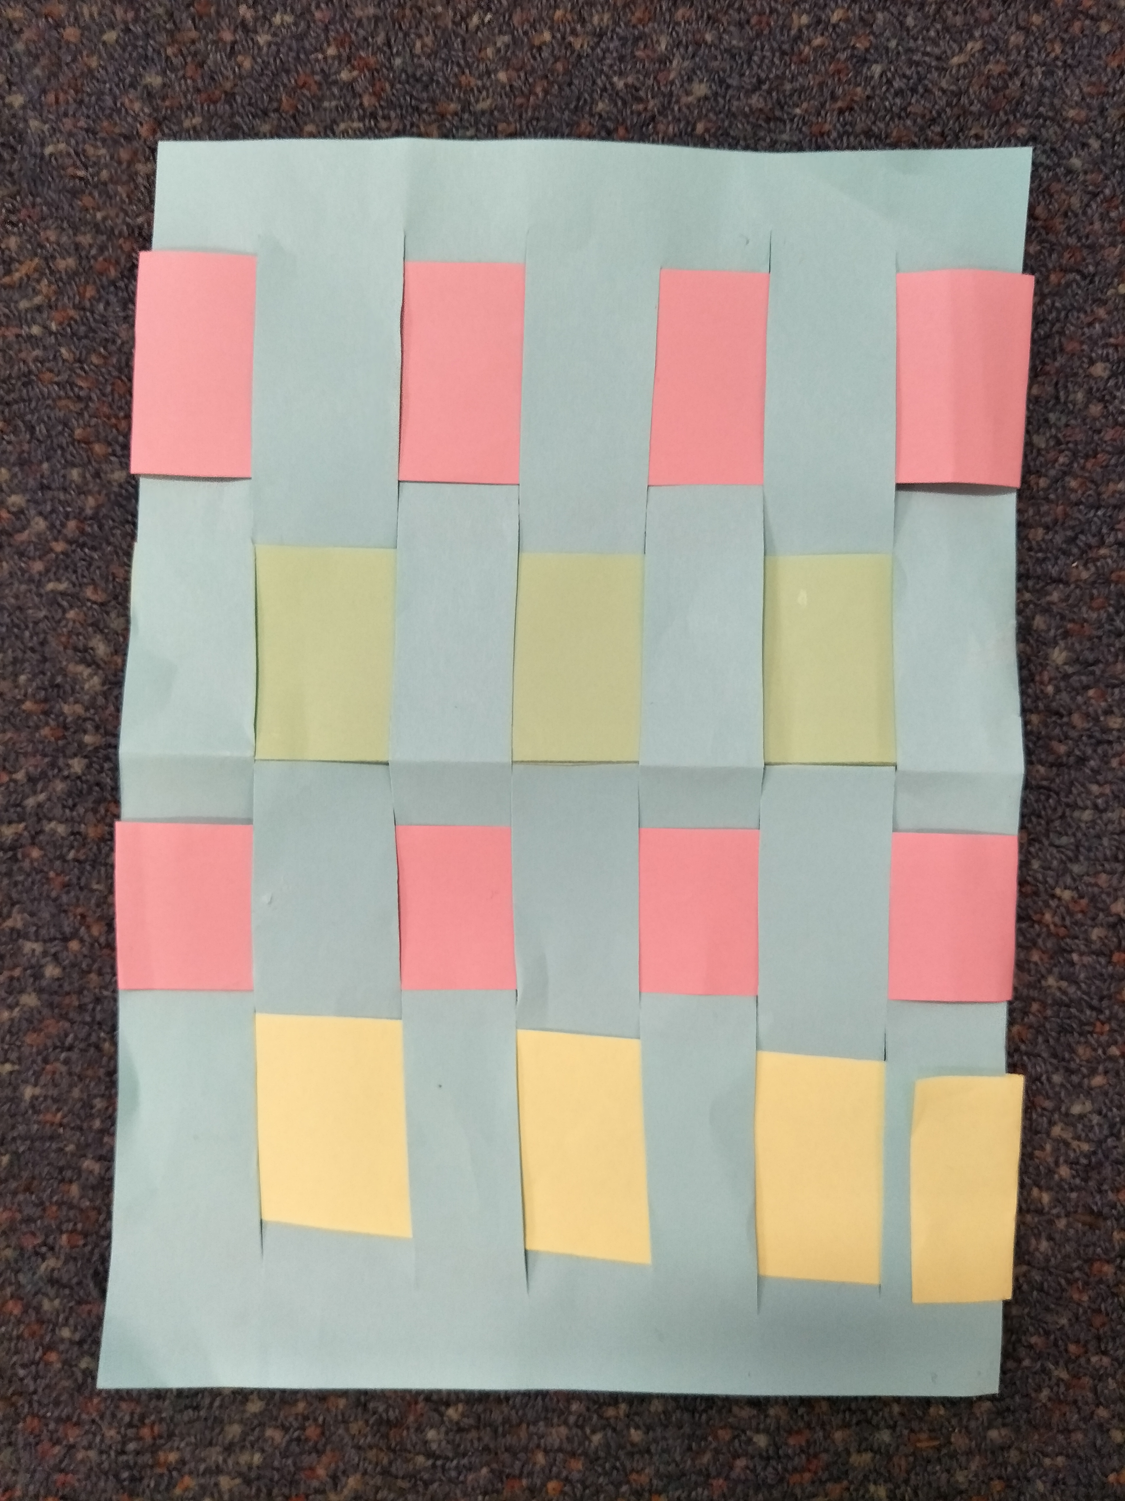

Check out the wonderful patterns we have made by following simple directions using the two positional words: **over** and **under**.