**5/6S believes that a Growth Mindset is key in achieving your goals this year. Here are some inspirational words from students in 5/6S to give you a strong start to the year.**

Practice makes progress not perfect.

* Sassy

Be yourself!

* Gab

Every day may not be good but there’s something good in every day

* 5/6S

The only difference between ordinary and extraordinary is that little extra.

* Siena

The only person you have to be better than is the person you were yesterday.

* Vivien

If you believe in yourself then you are already half way there.

* Dakota

Take a look at some of the artworks we have completed this term!

*The faces of 5/6S*

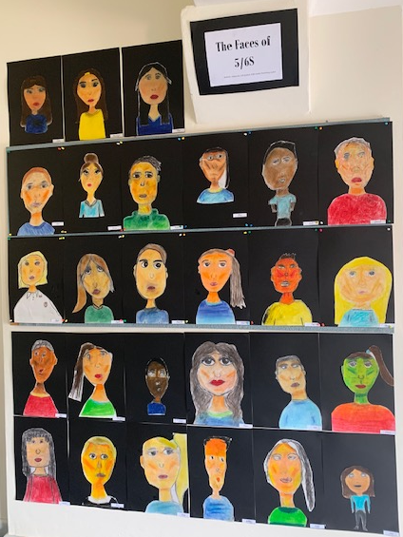

*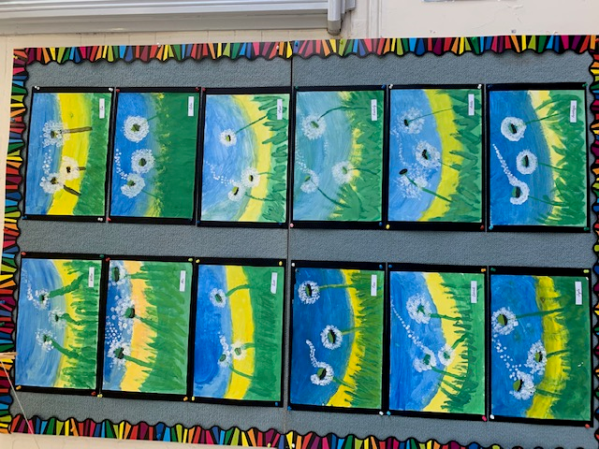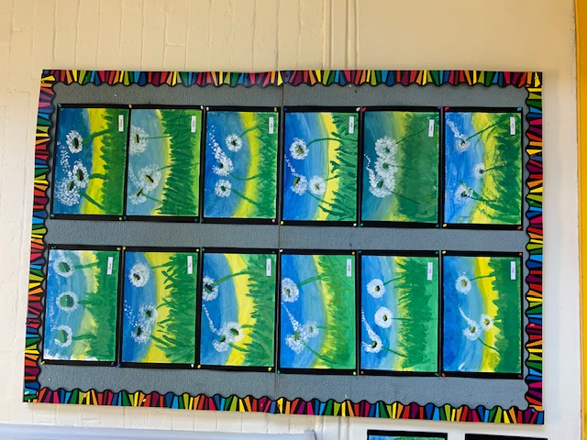Dandelions blowing in the wind*