Welcome to 2A
A is for
“Absolutely fabulous!” said Mrs Alam
Here is a snapshot of our recount writing from the end of Term One.
In Reading Groups, we do lots of incredible things. Our favourite thing to do is the listening post because we get to read along with the story.
By Anthony, Jennifer, Ethan
We have been printing in art. We have made origami fish, penguins, Chinese Dragons and Harmony Day doves. The best thing in art was the doves.
By Daniel and Jagger
In maths we have done so many things. I like the geo boards because we get to play with rubber bands and make 2D shapes. We also like doing maths number jigsaw puzzles. The hardest one is going up by threes. Maths adding cards are my favourite. I am getting better at adding nine to a number.
By Jennifer
In art this term we made penguins and put fur and googly eyes on it. It was amazing and so much fun.
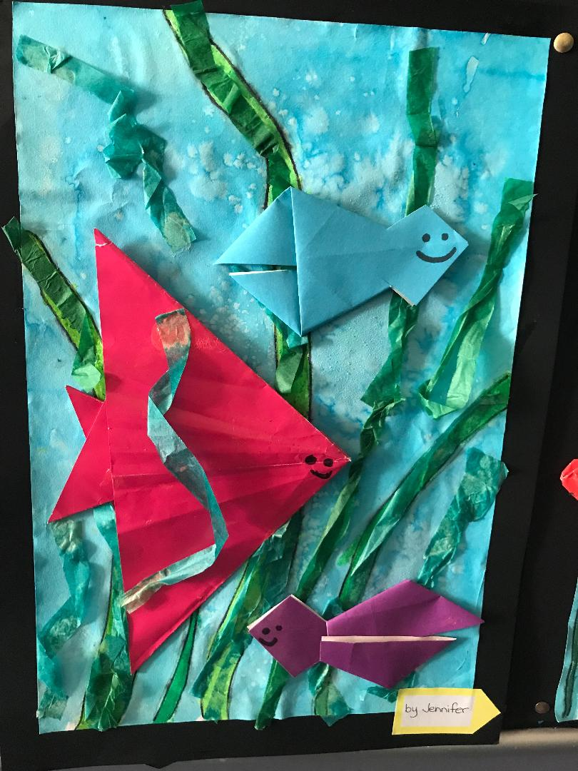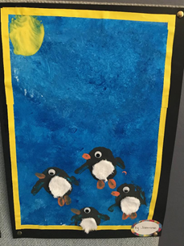
By William
This term in 2A I have learnt so many things. We have done many brainstorms. I have improved in handwriting and writing.
We made fairy bread in class and I put sprinkles on all my bread. It was so colourful. I ate some in class after that I went crazy! I loved it.
By Gemma and Cleopatra
In Sport this term we have done soccer, netball and basketball. Sport is an incredible subject. We have learnt so many different types of sports. I have realised that sport is one of my favourite things. Sport is super enjoyable.
By Elliana and Jasmine

Last week in Science we did a science experiment because we are going to write a recount about it. We did it with balls and the table. We started by blowing the ball across the table.
By Yeonhu
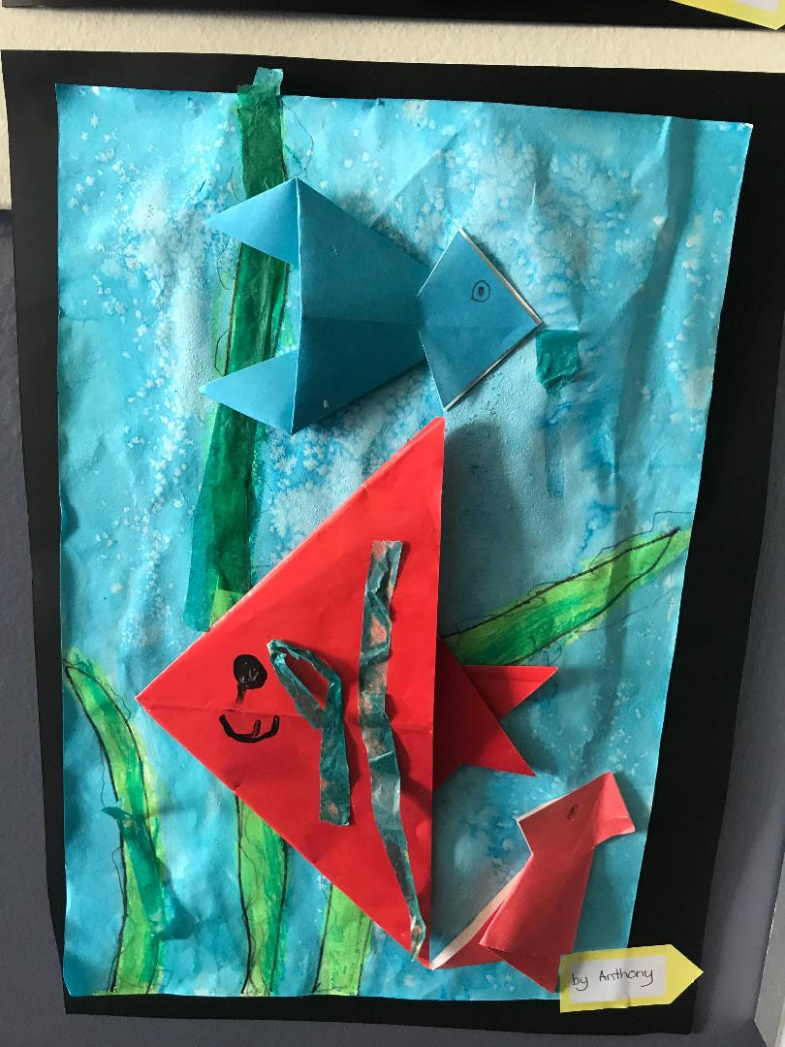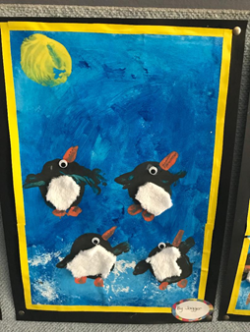

We have learnt to spell bigger words and to stop at full stops. 2A have learnt to use conjunctions and to make our sentences better. I love recount writing because you get to spell new words every day.
By Andie.
I like maths because we learn about new things. What do we do in maths? We do doubles, addition and subtraction. So, if you don’t know it’s a chance to learn. We also did smarties data, number problems, bridging, friends of ten, split strategy and they are all really good fun. We think maths is fabulous.
By Michael
In 2A we have done lots of things. Our favourite activities are reading groups and maths groups. Why do we like it? We like it because we get to do amazing activities.
By Sophia
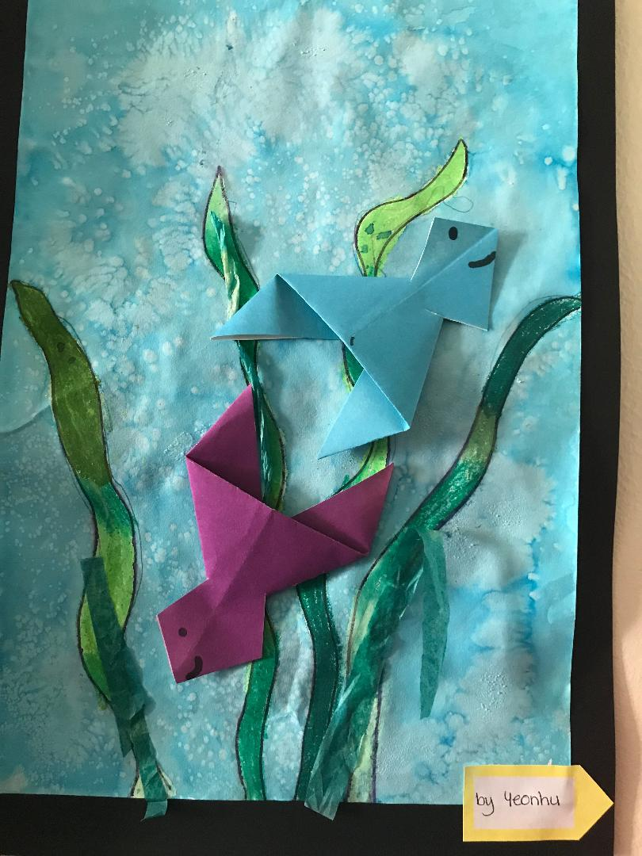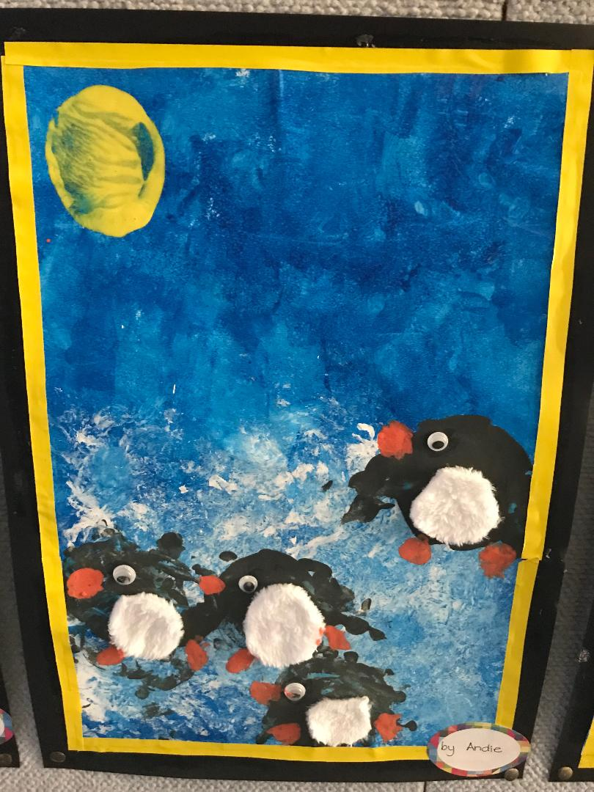
In maths groups we like all the activities but, our most favourite group is with Mrs Alam because we get to do more maths and show her our work. It is amazing playing and learning doing maths games and our favourite is number of the day. We get to have a fabulous time.
By Olivia

In Science, we have learnt about force, float, sink, gravity and force arrow diagrams. In writing, we have written a recount about the lighthouse keeper, making fairy bread and what we have done this term.
By Carissa
During Art we did lots of fun things, all these are my groups favourite things. We liked our Chinese Dragons. First, we coloured the head and then we put a coloured piece of paper for the body and put streamers on the back. We also liked our penguins. We sponged the background with blue paint then we got glad wrap and put white paint on it to make snow. Also, we got half a potato and stamped them to make penguin bodies and also the sun. Art is fantastic!
By Lily
Last week in 2A we did a science experiment. We had to make a ball go across the table without using our hands. We did this because we want to write a recount about it. We built a ramp using a book and a home reader box. It worked!
By Henry.
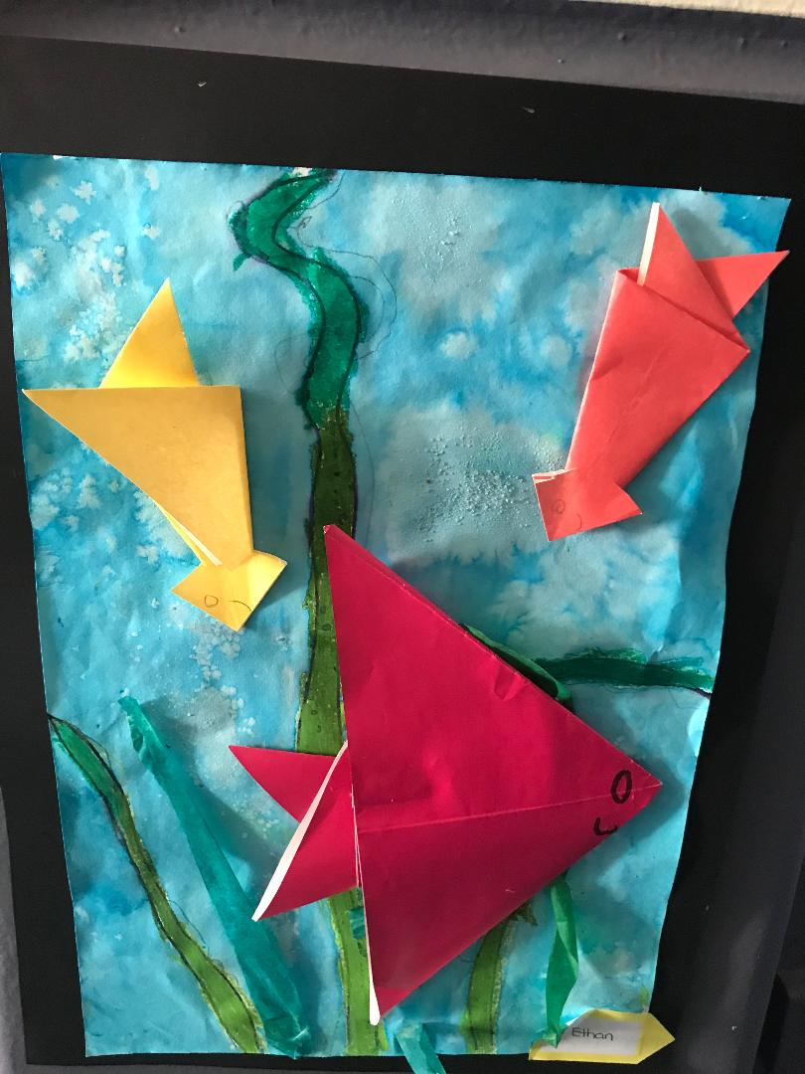
Jessica had the next great idea. She thought of lifting the table and making the ball roll down the table. It was so much fun; I like science experiments.
By Jessica
This term 2A have learnt so many things. We have improved in so many things, I like reading to Mrs Alam. 2A love doing new things every day. The class are improving in their punctuation, commas, exclamation marks and speech marks when people are talking.
We know how to answer maths problem in steps.
By Kristen
