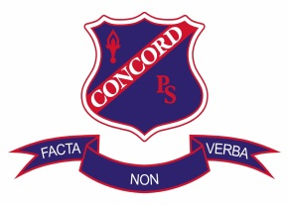
Concord Public School
66 Burwood Road, Concord NSW 2137 - P O Box 522 Concord NSW 2137
Telephone: (02) 9744 8427 or (02) 9744 8452 Fax: 9744 5187
Email: concord-p.school@det.nsw.edu.au

Scripture - 2021

Dear Parents/Carers,

At Concord Public School, students are taught by committed volunteer scripture and ethics teachers from our neighbouring organisations.

Please indicate below which class you would like your child to attend and return the note to your child’s teacher. Scripture classes will begin on Thursday, 25 February between 2:30pm – 3:00pm and continue throughout the year.

Thank you for your support.

Ms S Montgomery Ms A Vountoulas
Scripture Coordinator Principal

______________________________________________________________________________

Scripture Class - 2021

I give permission for my child _______________________________ of class____________
to attend:

Roman Catholic Scripture □
Islamic □ (Not confirmed, currently looking for a teacher)
Protestant □
Greek/Russian Orthodox □
Ethics Stages 2 & 3 Only □
Non-Scripture □

Parent/carer’s signature: _______________________________ Date: _____________

